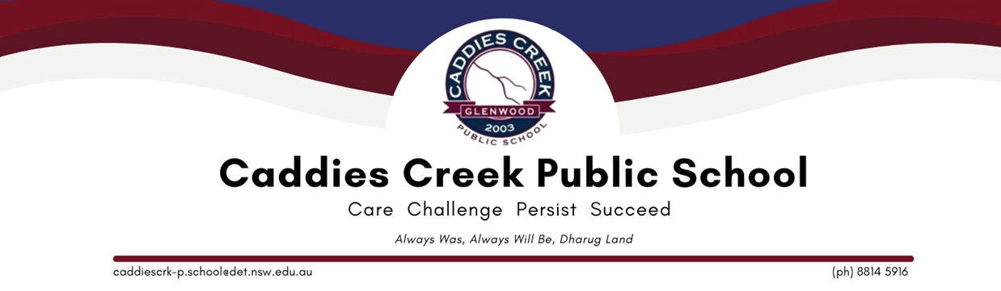

School Requirements 2023

Kindergarten Only
3 x wind up glue sticks
Paint shirt (preferably plastic backing)
All other materials e.g pencils etc are supplied for kindergarten students.

Optional donation: 1 box of tissues, 1 pump soap and paper towel

All Students in Years 1-6 will require:
1 x regular sized pencil case Coloured pencils
6 x HB lead pencils
3 x wind up glue sticks
Scissors – age appropriate
2x erasers
Pencil sharpener (enclosed with barrel to collect shavings)
30cm wooden or plastic ruler (no metal or bendable rulers)
1 pack of highlighters
2x whiteboard markers (blue or black) Library bag
Paint shirt
Overhead headphones for computer/iPad use – connection jacks will be supplied by the school where necessary

Optional donation: 1 box of tissues, 1 pump soap and paper towel

Additionally, students in Years 3-6 will also require:
1x A4 exercise book for homework
1 x thin sharpie for art
1x thin Artline pen for artwork Textas
Dictionary

Only Years 5/6 - Biro pens (not felt) blue and red x 3
Correct footwear and socks for school
These types of black footwear are appropriate for school, including lace up, buckles and velcro. These can be a sporting shoe as long as they are all black. Socks need to be folded/ankle socks.

Correct Types of Footwear ✓
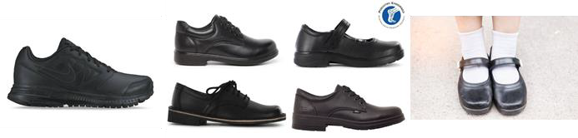

Incorrect Types of footwear ×

NO white soles or logos etc No cut off socks.
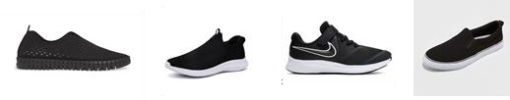

Students selected to represent the school are expected to be in correct school uniform including the shoes.

Sports Shoes

Students may wear any suitable sport shoe for school sport. These can be any colour however cannot be worn during the school week unless participating in school sporting activities (Years 3-6 Fridays only). Specialised sport shoes e.g. soccer boots & spikes are for representative games only. Students and families will be notified when specialized sport shoes can be worn.

